is currently Theatre in Residence at
The University of East London
trueheart.org.uk

University of East London, University Square, Stratford E15 1NF

http://www.universitysquarestratford.ac.uk/find-us.htm

How to find us:
University Square is located in the centre of Stratford, just 5 minutes' walk from Stratford station, and next door to the Theatre Royal and Picturehouse cinema.
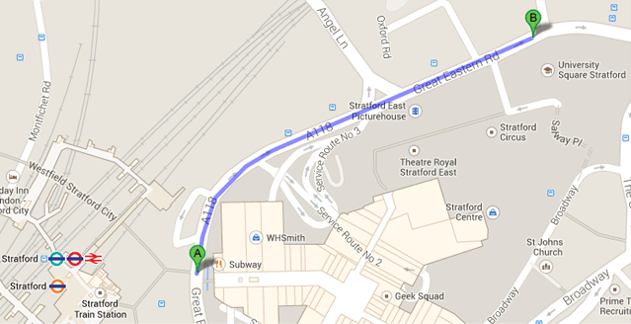
Stratford is served by the Central & Jubilee Lines & the DLR.

