**True Heart Theatre, Yellow Earth Theatre and The School of Creative and Liberal Arts, Regent’s University London with the support of the Hong Kong Economic and Trade Office London**

Macintosh HD:Users:veronicaneeda:Desktop:TSW Ensemble 2017:20A_ETO_20170324.pdf

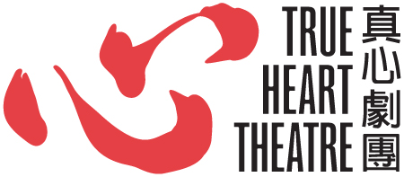 **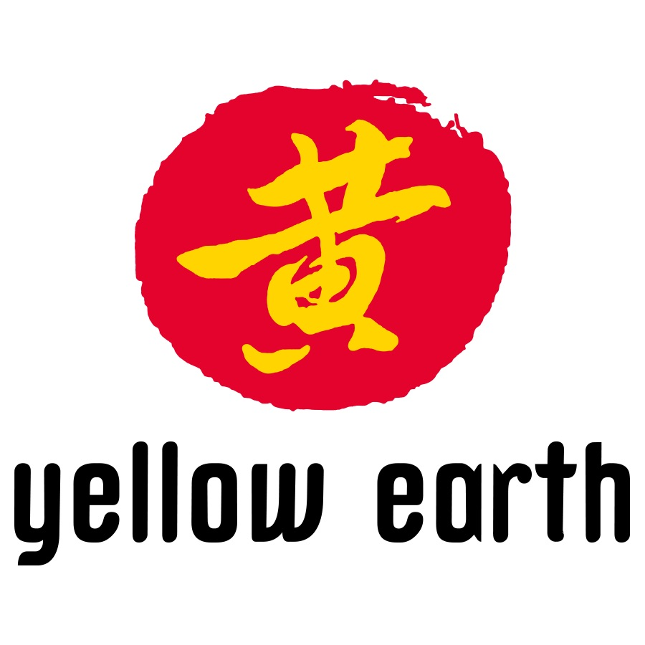** 

REGENT’S

UNIVERSITY LONDON

present

**CORPORAL AND SENSORY EXPERIENCE IN A PERFORMER’S BODY**

**A Workshop with TANG SHU WING**

**FRIDAY 28 JULY 2017**

**10am – 2pm**

**FREE**

REGENTS UNIVERSITY MARYLEBONE THEATRE – GARBUTT PLACE

<http://www.regents.ac.uk/media/2882334/regents-campus-map-2017.pdf>

Tang Shu-wing will share some of his thoughts and practice in training and inspiring his actors by enabling them to arrive at an internal point of transformation. However, this is not so much a workshop to train acting skills but more to create experience for the participants so that they can stretch their imagination, enhancing their power of feeling and expression through the body and the senses. Physicalisation, Deverbalisation and Devisualisation are the main tools of his methods. A routine training of the performers’ legs will be introduced to strengthen the body’s willpower. Two exercises on imagination and body memories through impossible tasks will be introduced to let the participants discover the unknown hidden in the subconscious.

Each participant should bring along a blindfold and should finish his/her breakfast one hour before the workshop.

**There will be a limited number of Participant and Observer places.**

**Please APPLY by sending your CV or brief biography - indicating your interest as Participant or as Observer, to** [**info@trueheart.org.uk**](mailto:info@trueheart.org.uk)

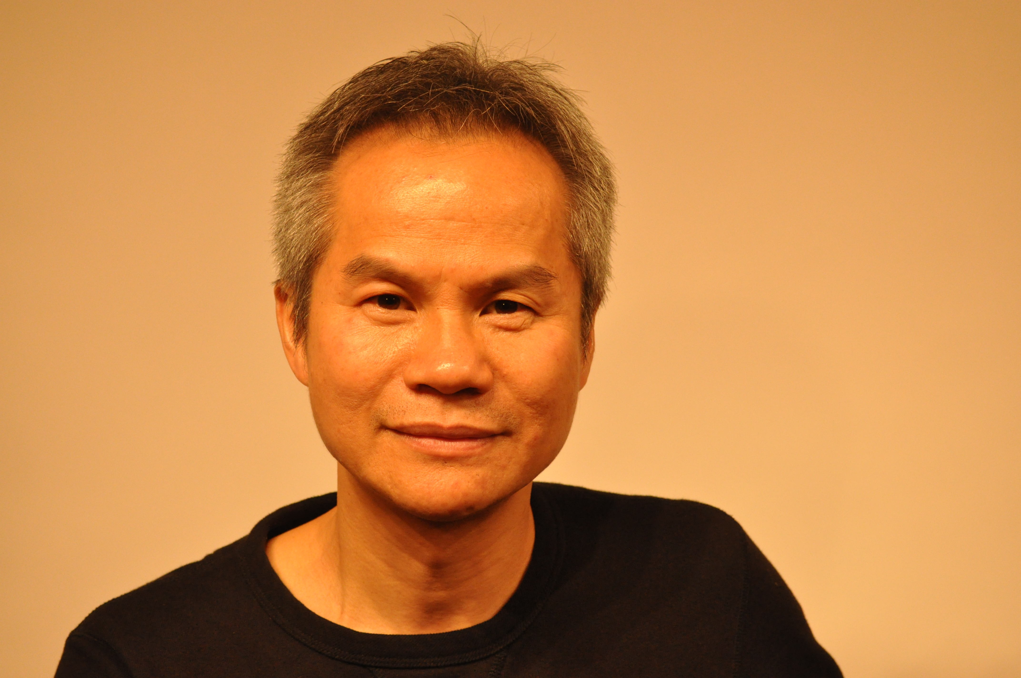About **TANG SHU-WING**

A world-class director, renowned theatre educator and veteran actor, Tang Shu-Wing is also former Dean of the School of Drama at the Hong Kong Academy for Performing Arts. Between 1986 and 1992, Tang studied in France where he received training in acting at l’Ecole de la Belle de Mai and his Maîtrise Diplôme in Theatre Studies from the Université de la Sorbonne Nouvelle in Paris. He also served as an assistant director and actor at the Théâtre de la Main d’Or in Paris before returning to Hong Kong. He is currently Artistic Director of Tang Shu-Wing Theatre Studio and Head of Programme of the first physical theatre training programme in Hong Kong.

Tang’s sources of influence are Meyerhold’s “theatre of the convention”, the “poor theatre” of Grotowski, tai chi and yoga. For him, theatre is a way to experience life through self-discovery. Dubbed the “Alchemist of Minimalist Theatre” and “one of the most talented theatre directors of Hong Kong”, Tang believes that a combination of physical theatre and minimalist aesthetics is the best way to realize his vision.   Tang has directed over fifty productions of drama, dance and opera. Representative works include *Phaedra*, *Hamlet*, *Princess Chang Ping*, *The Exception and the Rule*, *Titus Andronicus*, and *Titus Andronicus 2.0.*   Tang has received a number of professional awards, including the Chief Executive’s Commendation for Community Service Award (2012), the Outstanding Achievement in Direction for Dance Award at the Hong Kong Dance Awards (2013), and the Best Artist of the Year Award (Drama) from the Hong Kong Arts Development Council (2013). He was also named Honorary Fellow of Lingnan University, Hong Kong in October 2013, and recognised by Debrett's Hong Kong 100, a celebration of Hong Kong’s most inspiring and influential personalities.

藝術總監 鄧樹榮 Tang Shu-wing, Artistic Director <https://www.tswtheatre.com/studio>

**