PRESS RELEASE (in Chinese & English)

採訪通知 - FRIDAY 28/07/2017 - 3.30pm at Regents University’s Marylebone Theatre 7 Garbutt Place London W1U 4JD (Map attached)

香港得獎舞台劇搬上倫敦舞台
鄧樹榮重新演繹莎翁名作泰特斯2.0

香港劇團「鄧樹榮戲劇工作室」將於本年八月在倫敦劇院呈獻莎士比亞作品《泰特斯2.0》 。此劇為香港特別行政區成立20週年紀念系列節目之一，曾獲第十九屆香港舞台劇獎十大最受歡迎製作及最佳燈光設計，將以粵語演出並配以英文字幕。
鄧樹榮導演本周25日至29日將於倫敦籌備演出事宜，歡迎媒體朋友採訪報導，請儘快與我們聯絡，以便安排訪問。謝謝。

媒體查詢：Veronica / True Heart Theatre 電郵：info@trueheart.org.uk 電話：07779 945 991

採訪通知 - FRIDAY 28/07/2017 - 3.30pm at Regents University’s Marylebone Theatre 7 Garbutt Place London W1U 4JD (Map attached)
因檔期所限，鄧樹榮導演在演出期間將未能接受訪問，盼能體諒。

活動: 莎士比亞名劇《泰特斯2.0》
製作單位: 香港鄧樹榮戲劇工作室
演出地點: 英國 New Diorama Theatre
15 - 16 Triton Street, Regent's Place, London, NW1 3BF
日期: 八月四及五日（星期五及六）晚上七時三十分、
八月五日（星期六）下午二時三十分
票價: £15.50 及 £12.50(優惠人士)
http://www.newdiorama.com/whats-on/titus-andronicus-20

香港鄧樹榮戲劇工作室重演舞台劇獎十大最受歡迎製作《泰特斯2.0》
＊＊＊＊＊＊＊＊＊＊＊＊＊＊＊＊＊＊＊＊＊＊＊＊＊＊＊＊＊＊＊＊＊＊＊＊＊＊＊＊＊＊＊＊＊＊＊＊＊＊＊＊

香港劇團「鄧樹榮戲劇工作室」將於本年八月重新演繹莎士比亞作品《泰特斯2.0》 。此劇曾獲第十九屆香港舞台劇獎十大最受歡迎製作及最佳燈光設計。

2009年，鄧樹榮以嶄新、大膽的劇場手法，挑戰莎士比亞首個悲劇作品，將其改為說書方式，加入現場音樂及形體語彙，省去不必要的舞台元素，留下近乎空的舞台與簡潔的燈光，把焦點回歸劇場核心。七張椅子以及七名穿梭於說書人與角色之間的表演者，對劇場的各種可能進行一次冒險的探索，帶領觀眾踏上一段自我反省、覺醒及淨化心靈之旅。

鄧樹榮形容：「《泰特斯2.0》回歸到中、西劇場的起點──述說及表演故事，從而對劇場的各種可能性進行一次最冒險的探索。」鄧在創作過程中，以密集式的整體協作訓練及即興實驗，演化出不同的說書形式，承載著表演者由內而發的身體能量，並以各種肢體語言將之呈現。

《泰特斯》為莎士比亞首個悲劇作品，內容血腥，時至今日依然備受爭議。故事講述羅馬將軍泰特斯大敗哥特王國，羅馬新帝欲娶泰特斯女兒拉維尼婭為妻，但遭反對，遂改為迎娶戰敗國女皇塔摩拉為后。塔摩拉與其黑奴為報亡國之痛，著兒子們強暴拉維尼婭。泰特斯裝瘋扮儍，走上復仇的不歸路……

《泰特斯2.0》由香港演藝學院戲劇學院前院長鄧樹榮執導，演員包括彭珮嵐、黃兆輝、黃珏基、杜雋饒、黎玉清、黃月兒、岑軍諺。此劇於二○○九年香港首演後，更於歐亞六個城市巡迴演出。

鄧樹榮戲劇工作室《泰特斯2.0》以粵語演出配以英文字幕，為香港特別行政區成立20週年紀念系列節目之一，於八月四及五日（星期五及六）晚上七時三十分、八月五日（星期六）下午二時三十分在英國 New Diorama Theatre 公演。票價為£15.50 及 £12.50(優惠人士)。每場均設演後座談讓觀眾可以與本節目演員交流。本節目部分情節可能令人情緒不安，適合十二歲或以上觀眾欣賞。

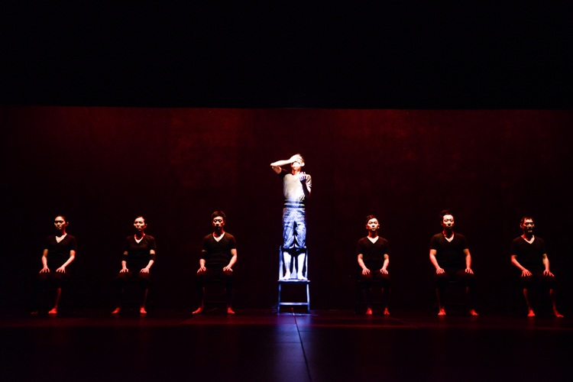
圖片下載: http://pswu.com/media/TSW/Titus_2.0-2280.jpg

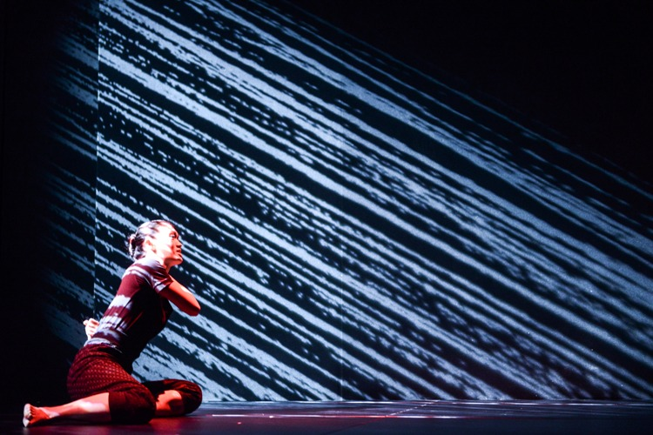
圖片下載: http://pswu.com/media/TSW/Titus_2.0-2246.jpg

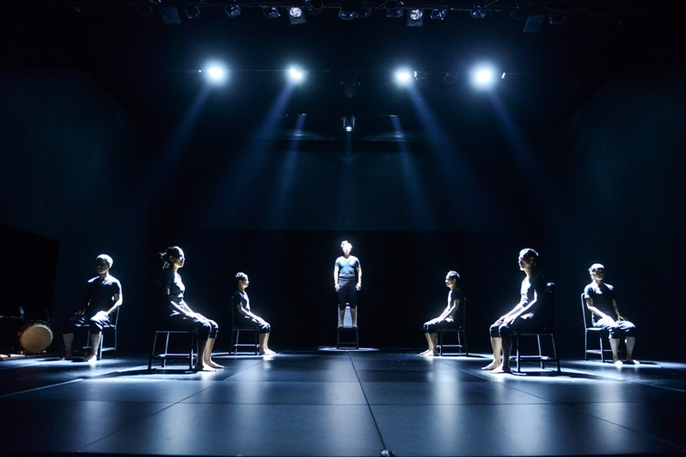
圖片下載: http://pswu.com/media/TSW/Titus_2.0-2545.jpg

藝術總監
鄧樹榮

國際級導演、知名 戲劇 教育家、資深演員、香港演藝學院 戲劇學院前院長，一九八六至九二年 留學法國 ， 於巴黎 Ecole de la Belle de Mai接受演員訓練，並在新索邦大學 獲戲劇 碩 士 ，回港前曾於巴黎金手劇團任助理導演及演員。現為「鄧樹榮戲劇工作室」藝術總監 ，為香港首個一年制形體戲劇訓練課程 作課程總設計 及 導 師 。

鄧氏深受梅耶荷德「假定性戲劇」、葛羅托斯基「質樸劇場」、太極以及瑜伽的啟發，透過簡約美學手法，進行形體劇場創作。其獨特的風格為他帶來「簡約劇場煉金術士」的美譽。他亦曾獲法國文化協會的《東西譚》雜誌形容為「香港最具才華的劇場導演之一」。

鄧樹榮曾導演超過五十項戲劇、舞蹈及歌劇，其代表作包括《菲爾德》（2005）、《哈姆雷特》（2006）、《帝女花》（2007劇場版及2009舞蹈版）、《例外與常規》（2008）、《泰特斯》（2008，2012）、《泰特斯2.0》（2009，2012）、《亞瑟王》（2009）、《魔方變奏》（2010）、《打轉教室》（2011，2012，2013，2014，2015）、《舞．雷雨》（2012，2013，2014，2015）及《你為甚麼不是Steve Jobs?》（2014）。其作品曾於香港及世界各地演出。二零一五年三月，他導演香港藝術節歌劇《大同》；五月, 為澳門藝術節導演《菲爾德2.0》；八月 ，再度獲莎士比亞環球劇場邀請，前往倫敦以粵語首演《馬克白》，並獲邀於愛丁堡藝穗節重演《打轉教室》；九月，他回歸香港重演《泰特斯2.0》。二零一六年三月，《馬克白》為香港藝術節節目之一，作香港首演；五月，應白光劇社邀請導演《安提戈涅》於北京演出。

二零零一年，他出版了《梅耶荷德表演理論：研究及反思》及《生與死三部曲之劇場探索》。二零零四年，國際演藝評論家協會香港分會出版了研究鄧樹榮作品的專著：《合成美學──鄧樹榮的劇場世界》。二零一四年，鄧樹榮出版了《泰特斯──簡約美學與形體劇場》及《打轉教室──完全出於好奇》，前者展示了簡約美學作為風格取向，形體劇場作為創作手法如何成就《泰特斯》和《泰特斯2.0》這兩個當代亞洲劇壇不能忽視的作品。二零一六年，出版了《書寫塞納河開始：我對劇場的思辨與演繹》。

曾獲的專業獎項包括一九九三年塔什干國際戲劇節優異演繹獎，一九九三年香港舞台劇獎優異另類演出獎，二零零三年香港舞台劇獎最佳男主角獎（悲／正劇），三屆（2006，07，11年）香港舞台劇獎最佳導演獎，二零零八年香港藝術發展局藝術成就獎（戲劇）。其他獎項包括一九九七年亞洲文化協會謝普誠獎助金，二零零七年香港特別行政區政府民政事務局局長嘉許獎狀，二零零七年法國文化部「藝術及文學軍官勳章」（L’Officier de l’Ordre des Arts et des Lettres）；二零一零年獲《瞄》雜誌頒發「文化大件事」獎；二零一二年獲中國《南方都市報》「深港生活大獎」之「年度藝文人物獎」，同年更獲香港特別行政區行政長官社區服務奬狀；他於二零一三年四月獲香港舞蹈年獎最值得表揚劇作指導獎及香港藝術發展局「2012香港藝術發展獎年度最佳藝術家獎」（戲劇），同年十月獲香港嶺南大學榮譽院士。二零一五年獲委任為西九文化區管理局轄下諮詢會成員，同時為現任香港舞蹈團及香港藝術發展局的榮譽藝術顧問及康樂及文化事務署藝術節主席。

PRESS CONFERENCE
FRIDAY 28/07/2017 - 3.30pm at Regents University’s Marylebone Theatre 7 Garbutt Place London W1U 4JD (Map attached)

Hong Kong’s acclaimed Tang Shu-wing Theatre Studio to re-run its award-winning Cantonese production of "Titus Andronicus 2.0" in London on 4 & 5 August 2017.

Titus Andronicus 2.0
in Cantonese with English surtitles will be presented at the
New Diorama Theatre
15 - 16 Triton Street, Regent's Place, London, NW1 3BF
on 4 & 5 August
Friday at 7.30pm and Saturday 2.30pm & 7.30pm
Tickets: £15.50, £12.50 (concessions)
http://www.newdiorama.com/whats-on/titus-andronicus-20

The highly acclaimed Tang Shu-wing Theatre Studio from Hong Kong will perform its ground-breaking version of Shakespeare's "Titus Andronicus” on Friday 4 (7.30pm) and Saturday 5 (2.30pm & 7.30pm) August at the New Diorama Theatre, 15-16 Triton St, Regent's Park, London NW1 3BF.
Created in 2009 in Hong Kong, Titus Andronicus 2.0 is a bold and revolutionary attempt to explore the unreleased potentials of Shakespeare’s play by rewriting it into a narrative and physicalizing the act of story-telling in various non-representational ways.

Tang focuses on the very essence of theatre – bringing the actors in front of the spectators – with just a bare stage, live music, seven chairs and seven actor-narrators who switch between narrating the action and embodying the characters with intense physicality.

Titus Andronicus 2.0 leads audiences through the black hole of the human psyche into a world of primal energy, boundless imagination, self-reflection, self-discovery and cathartic peace.

Tang Shu-wing says “this is an adventure for possibilities of theatre through a journey to the source, returning to the origin of both Eastern and Western theatre in which stories were told and performed.”

Titus Andronicus 2.0 is directed by Tang Shu-wing, world-class director, renowned theatre educator and veteran actor, and former Dean of the School of Drama at the Hong Kong Academy for Performing Arts. The main cast includes Andy Ng, Eric Tang, Masu Wong, Leung Ka-wai, Chu Pak-hong, Lai Yuk-ching and Ivy Pang. The play was taken on tour to six cities in Europe and Asia after its premiere in Hong Kong in 2009. It was very warmly received at the World Shakespeare’s Festival at the Globe Theatre in 2012. Londoners are able to see it again on its European tour this year as part of celebrations of the 20th anniversary of Hong Kong’s return to China. It is performed in Cantonese with English surtitles.

A question and answer opportunity for the cast and the audience will follow each of the three performances in London. It is suitable for ages 12 or above.

“The entire audience is led to the inner world of the text by a powerful eddy of narration and physical acting” Cup Magazine, (Hong Kong)

“Tang’s minimalist approach works beautifully for a maximalist play... Less is really more”
The Strait Times, (Singapore)

The project is sponsored by the Hong Kong Economic and Trade Office, London as part of the programme to commemorate the 20th anniversary of the establishment of the Hong Kong Special Administrative Region. It is also supported by the Arts Development Fund of the Home Affairs Bureau and the Hong Kong Arts Development Council, the Government of the Hong Kong Special Administrative Region.

ENQUIRIES to Veronica True Heart Theatre info@trueheart.org.uk 07779 945 991

Additionally, Tang Shu-wing will be leading a special WORKSHOP for theatre professionals

Corporal and Sensory Experience in a Performer’s Body

on Friday 28 July (10am-2pm)
at the Regents University’s Marylebone Theatre – Garbutt’s Place.

Tang Shu-wing will share some of his thoughts and practice in training and inspiring his actors by enabling them to arrive at an internal point of transformation. However, this is not so much a workshop to train acting skills but more to create experience for the participants so that they can stretch their imagination, enhancing their power of feeling and expression through the body and the senses. Physicalisation, Deverbalisation and Devisualisation are the main tools of his methods. A routine training of the performers’ legs will be introduced to strengthen the body’s willpower. Two exercises on imagination and body memories through impossible tasks will be introduced to let the participants discover the unknown hidden in the subconscious.

Each participant should bring along a blindfold and should finish his/her breakfast one hour before the workshop.
There will be a limited number of Participant and Observer places.
Please APPLY by sending your CV or brief biography - indicating your interest as Participant or as Observer, to info@trueheart.org.uk

This event is free of charge and co-presented by True Heart Theatre, Yellow Earth Theatre, Regents University and the Hong Kong Economic and Trade Office, London.

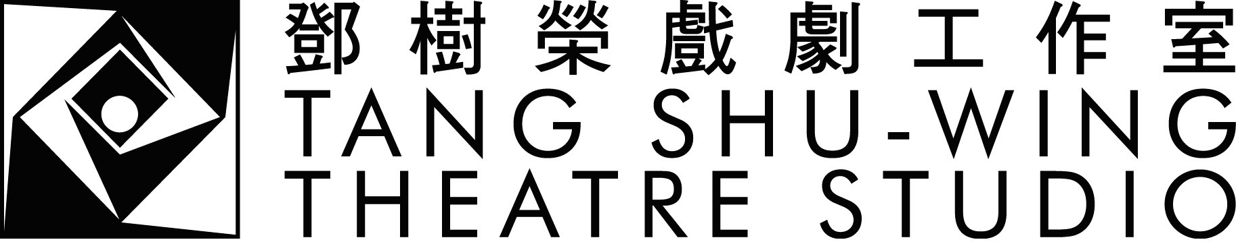

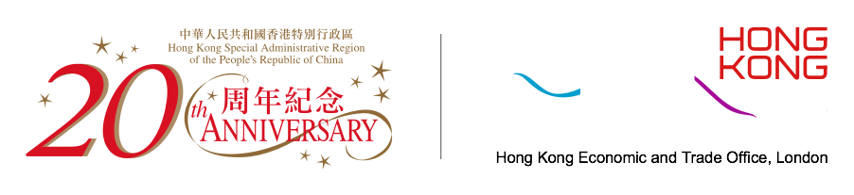
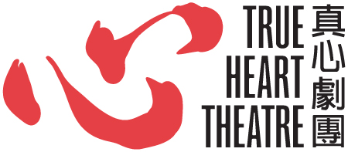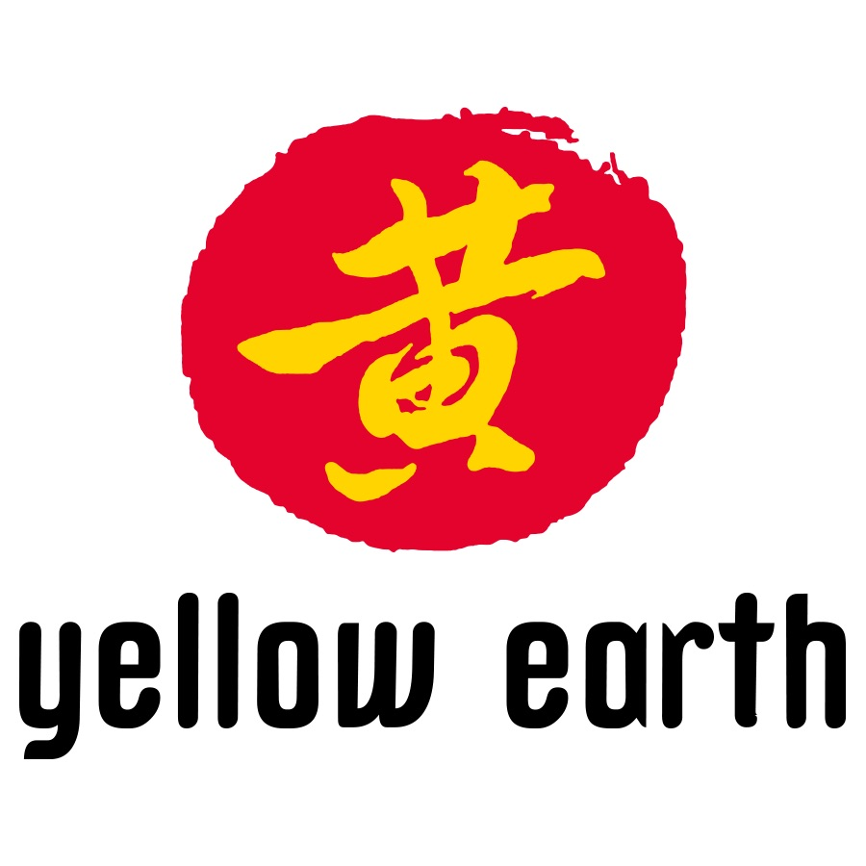
REGENT’S
UNIVERSITY LONDON

About TANG SHU-WING
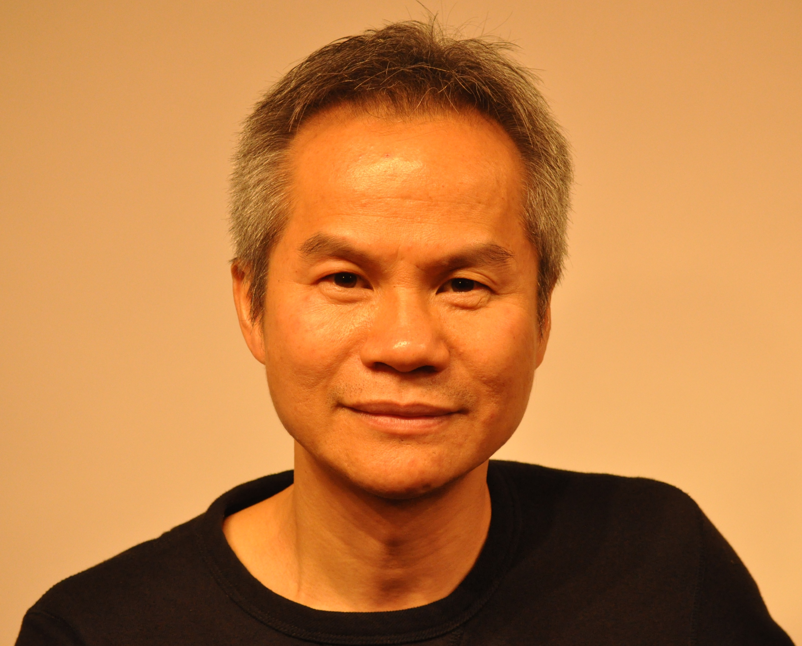
A world-class director, renowned theatre educator and veteran actor, Tang Shu-Wing is also former Dean of the School of Drama at the Hong Kong Academy for Performing Arts. Between 1986 and 1992, Tang studied in France where he received training in acting at l’Ecole de la Belle de Mai and his Maîtrise Diplôme in Theatre Studies from the Université de la Sorbonne Nouvelle in Paris. He also served as an assistant director and actor at the Théâtre de la Main d’Or in Paris before returning to Hong Kong. He is currently Artistic Director of Tang Shu-Wing Theatre Studio and Head of Programme of the first physical theatre training programme in Hong Kong.

Tang’s sources of influence are Meyerhold’s “theatre of the convention”, the “poor theatre” of Grotowski, tai chi and yoga. For him, theatre is a way to experience life through self-discovery. Dubbed the “Alchemist of Minimalist Theatre” and “one of the most talented theatre directors of Hong Kong”, Tang believes that a combination of physical theatre and minimalist aesthetics is the best way to realize his vision.
Tang has directed over fifty productions of drama, dance and opera. Representative works include Phaedra, Hamlet, Princess Chang Ping, The Exception and the Rule, Titus Andronicus, and Titus Andronicus 2.0.
Tang has received a number of professional awards, including the Chief Executive’s Commendation for Community Service Award (2012), the Outstanding Achievement in Direction for Dance Award at the Hong Kong Dance Awards (2013), and the Best Artist of the Year Award (Drama) from the Hong Kong Arts Development Council (2013). He was also named Honorary Fellow of Lingnan University, Hong Kong in October 2013, and recognised by Debrett's Hong Kong 100, a celebration of Hong Kong’s most inspiring and influential personalities.
藝術總監 鄧樹榮 Tang Shu-wing, Artistic Director https://www.tswtheatre.com/studio

